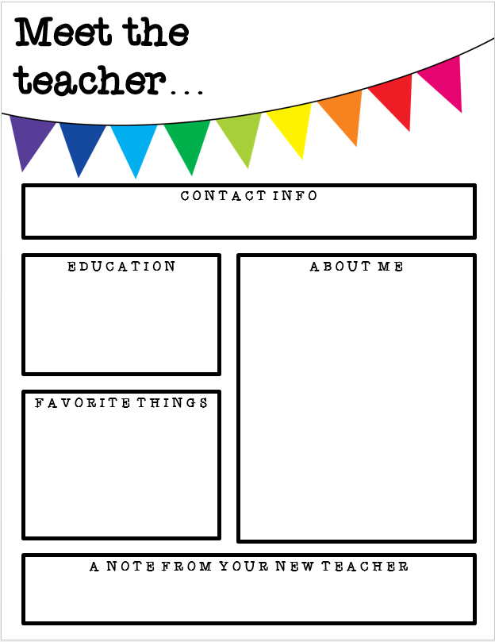

Dear Students and Parents,

Welcome to fifth grade! I hope this letter finds you all filled with anticipation and excitement for the upcoming school year. My name is Susan Martin, and I will be your teacher this year. I am thrilled to embark on this journey with each one of you.

Fifth grade is a pivotal year in the elementary school experience. It is a time of growth, both academically and personally. Together, we will explore a variety of subjects and engage in meaningful learning experiences that will prepare students for the challenges and successes that lie ahead.

In our classroom, we will dive deep into mathematics, sharpening our problem-solving skills, and discovering the beauty of numbers. We will explore the world of science, conducting experiments and unraveling the mysteries of the natural world. Language arts will take us on incredible adventures through literature, as we analyze stories, develop our writing skills, and expand our vocabulary. Social studies will transport us through time and space, allowing us to understand the history of our nation.

But fifth grade is not just about academics. It is also about building character, fostering friendships, and developing important life skills. We will work together to create a nurturing and inclusive classroom environment where everyone feels valued and respected. Collaboration, empathy, and perseverance will be key values that we uphold throughout the year.

Parents, your support and involvement in your child's education are crucial. I encourage open lines of communication and partnership between home and school. Together, we can ensure that your child receives the best possible education and support to reach their full potential. I will keep you informed about classroom activities, assignments, and any important updates throughout the year.

I am truly honored to be your fifth-grade teacher, and I am committed to making this a memorable and impactful year for each of you. Let's embrace the challenges, celebrate our achievements, and make this a year of growth and discovery. I look forward to getting to know each of you, learning alongside you, and creating a positive and engaging learning environment.

Please feel free to reach out to me with any questions, concerns, or ideas you may have. Let's work together to make this year an incredible journey of learning and personal growth.

Here's to an amazing year in fifth grade!

Warmest regards,

Susan Martin